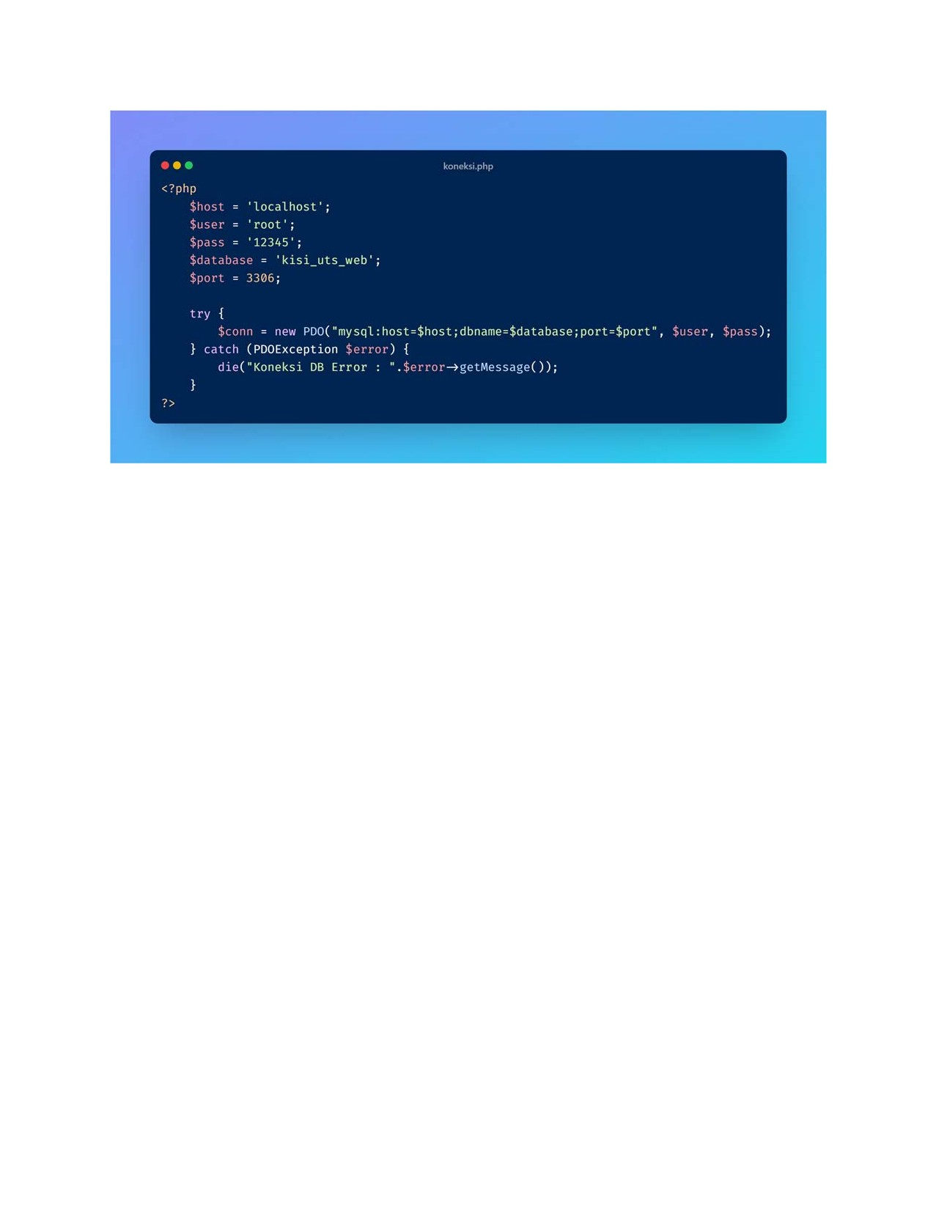
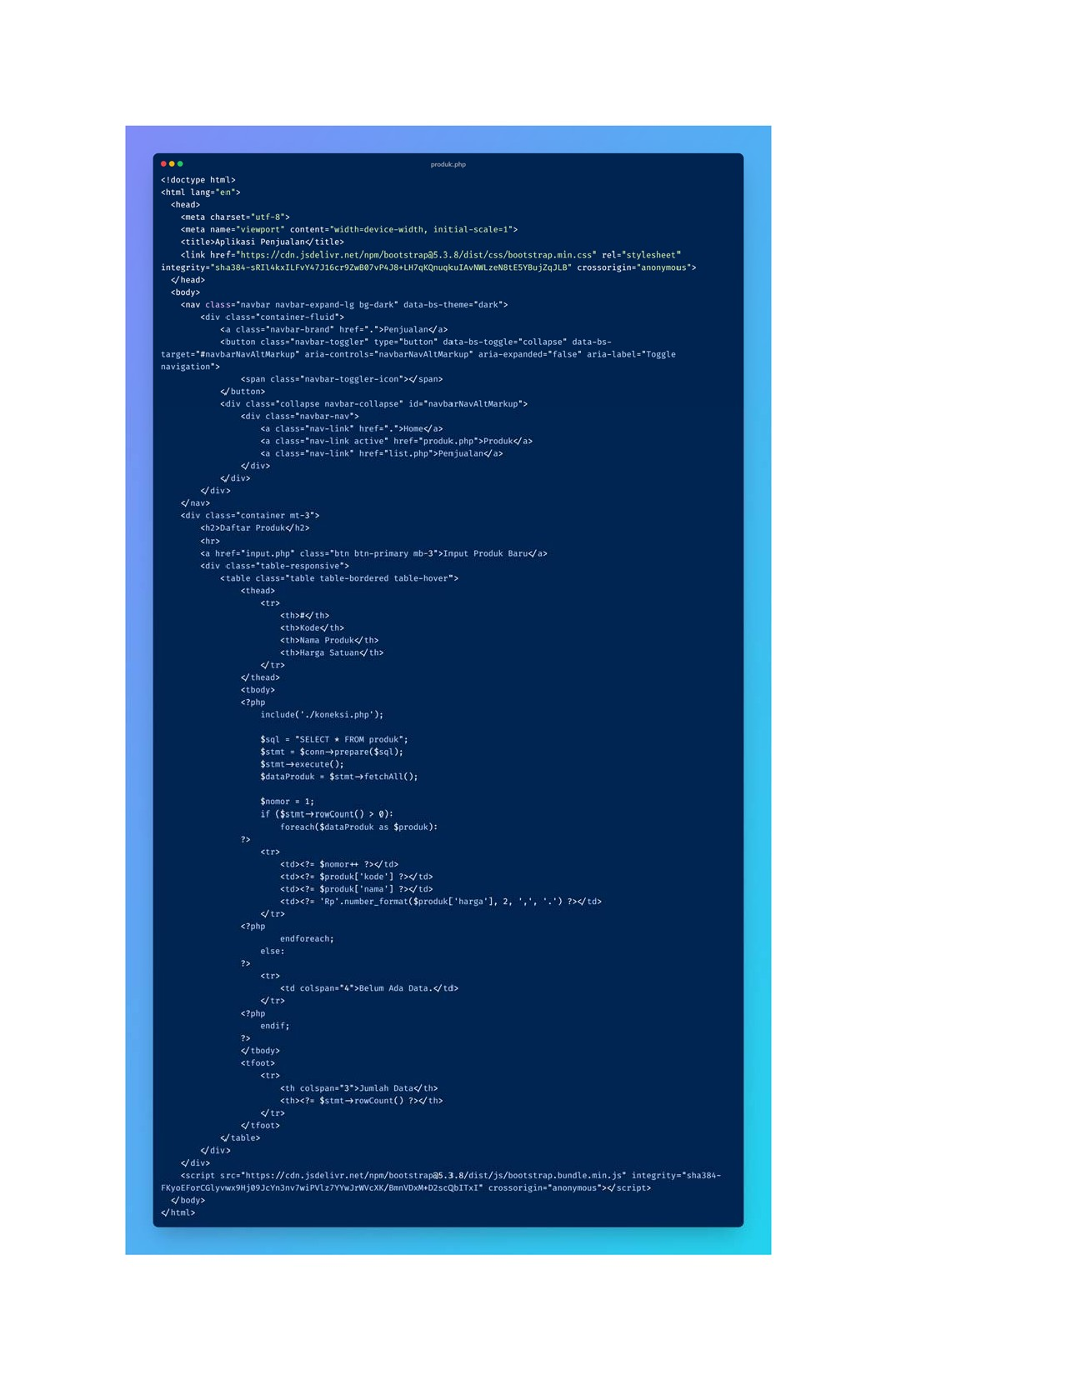
?php
Spesan
if l)) php
Skode
Snama
$ h arga
$sql •INSERT INTO produk :nama, :harga)• ;
Sstmt
SS impan
Skode,
• nama• $nama,
Sharga n;
if ($simpan)
$ pesan •produk berhasit • ;
$pesan •produk gagal disimpan.";
htmU>
Chtml
sneta name: •viewport• content ± •width—device-Kidth, initial
Ctitle>ApUikasi penjuaIanUtitIe>
Oink href=•https://cdn.jsdeIivr.net/np•/bootstrap05.3.8/dist/css/bootstrap.min.css•
e/ head)
<bodp class: •navbar navbar-expand—lg bg-dark•
(div href=
<button lapse • data-bsaria-expanded: •false" aria-label • Toggle
sspan e but ton >
•:div class-•coUapse navbar-coUapse• id-•navbarNavAItMarkup•»
<div
h ref— • classe•nav-link active'
c/div» Udiv>
<div class-•container mt-3%•
e?php
<div c?php end if;
action: •g • method: •post %
<div 3
< label forz•kode• class: •form-label • 'Kode ProdukVIabeI>
<input required autofocuS>
<div 3 fore •nana • produkVlabel> cinput type-•text• class: •form-controt• required>

(div 3
Clabel fort•harga• class" form-label •>Harga Satuandlabel>
< input idz•harga• classz•foæ-controt• requi red'
Kbutton type: •submit• classz"btn

Q form* Udiv> escript integrity:•s ha 384 —
FKyoEForC61yn.x9H3e9JcYn3nv7xiMz7YYOrweXK/8anvoxN+02scqb1Tx1• body'

U h tot'
